Day 6 – Sample Bug Flow in real scenario
Learn
- Custom fields (what companies customize)
Custom fields are used to capture additional information required by organizations that is not available by default in Jira. Companies customize fields based on project, domain, and reporting needs.Real bug tracking flow
- Real Bug Tracking Flow
Understood the complete bug lifecycle followed in real projects from reporting to closure.
- Typical bug flow practiced:
New -> Assigned -> Open -> Fixed -> Testing -> Verified -> Closed.
Practical
- Added a custom field (Severity)
Created a custom field named Severity to classify bugs based on impact.
- Created bugs with:
  - Steps to reproduce
Use a clear structure so developers can understand and reproduce the issue.
Example: For a bug – Login fails for valid credentials
Steps to Reproduce
- Open the application.
- Navigate to the Login page.
- Enter valid username and password.
- Click the Login button.
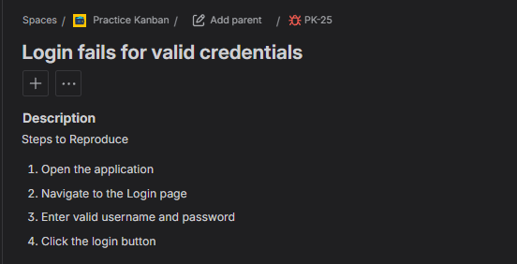
  - Expected vs actual result
Example: For a bug – Login fails for valid credentials
Expected Result
User should be logged into the application with valid username and password and redirected to the dashboard.
Actual Result
Login fails for valid username and password.
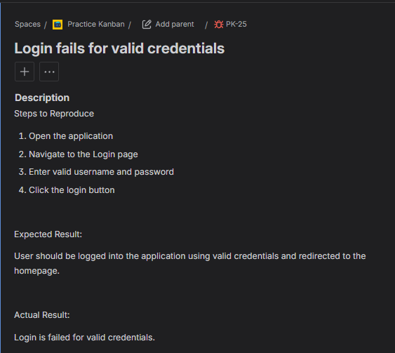

- Practiced realistic bug movement across workflow statuses.

Typical Bug Workflow Used
New → Assigned → Open → Fixed → Testing → Verified → Closed

Step 1: New / Open
- Bug is created by QA.
- Status is New or Open.

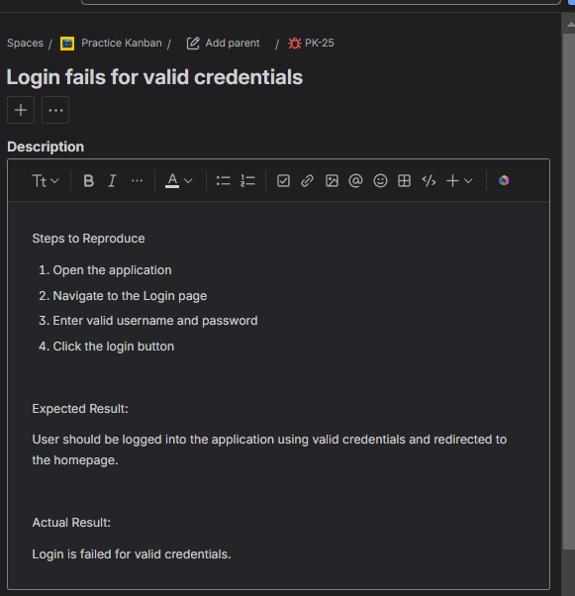

Step 2: Assigned
- Bug is assigned to a developer.
- Developer reviews the issue.

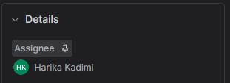

Step 3: In Progress
- Developer starts working on the fix.
- Status moved to In Progress.

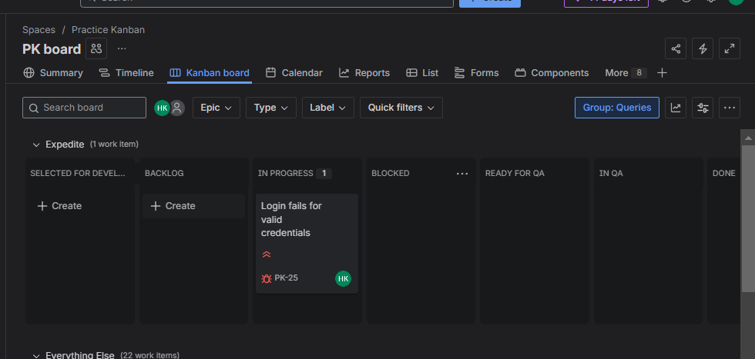

Step 4: Fixed
- Developer fixes the issue and updates the bug.
- Status moved to Fixed.

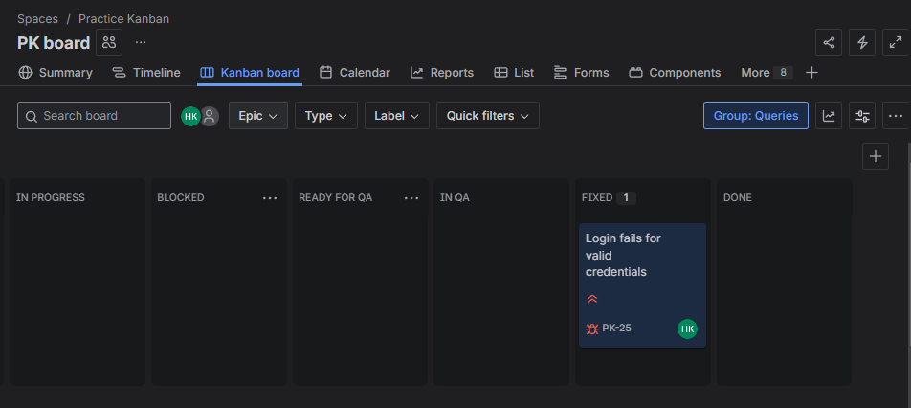

Step 5: Testing
- QA retests the bug in test environment.
- Status moved to Testing.

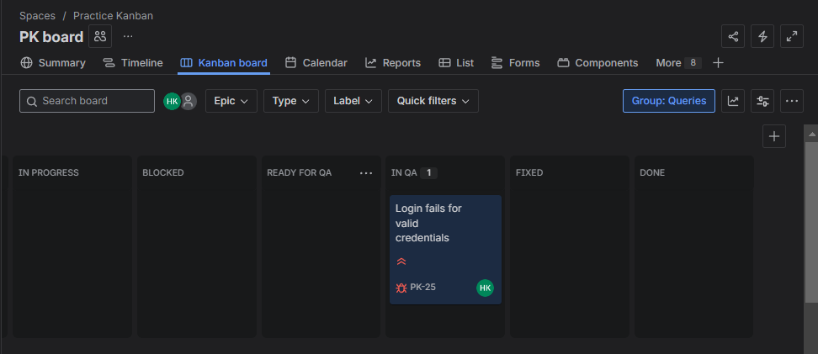

Step 6: Verified and closed

